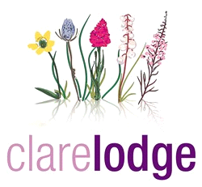


Statement of Purpose and Function

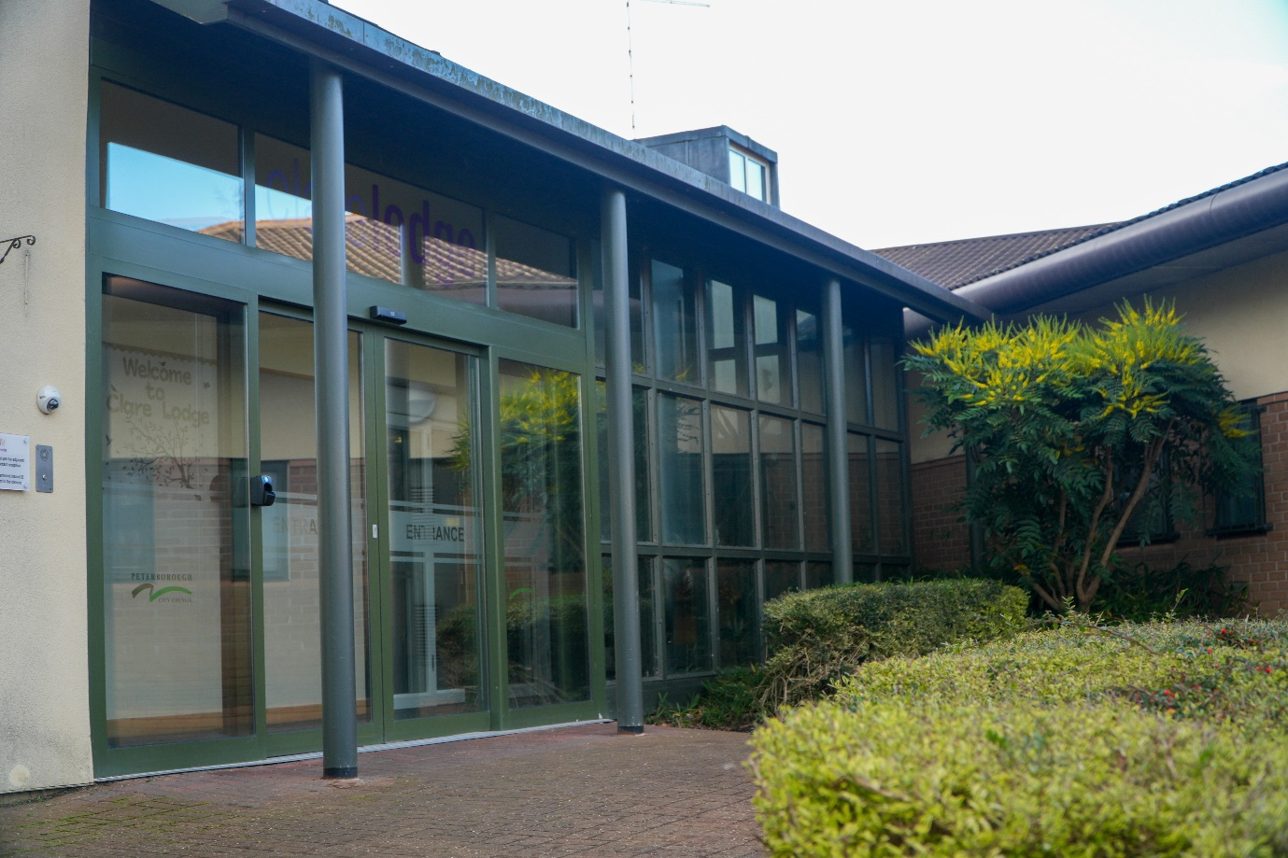

Owned and operated by Peterborough City Council

Contents

02 Introduction
03 Management and Monitoring
03 Overall Aims
06 Services and Facilities
09 Type of accommodation provided
11 The Name / Qualifications of the Registered Manager & Responsible Individual
11 Staffing
12 The Organisational Structure of the Home
13 Meetings
14 Arrangements for Supervision and Staff Training
15 Criteria for Admission, Referral Process, & Placement
17 Education
19 Health arrangements
21 Participation in Recreational, Sporting, and Cultural Activities
22 Measures of Control
24 Arrangements for Child Protection and to Counter Bullying
26 Unauthorised Absence
26 Surveillance
27 Fire Precautions / Emergency Contingency
27 Cultural Diversity/Religious Observance
28 Contact
29 Complaints and Representations
30 Statutory Reviews and Meetings
32 Details of Therapeutic Techniques
33 Anti Discriminatory Practice
34 How to Find Clare Lodge / Maps
37 Appendix One Staffing structure
38 Appendix Two Charter of rights

Introduction

Clare Lodge Secure Children’s Home maintains this Statement of Purpose and Function in accordance with the requirements of Children’s Home (England) Regulations 2015. It describes the aims and objectives of the Home, the manner in which services are provided, staffing, and care practices.

Clare Lodge provides a Secure Accommodation service registered for up to 16 young people aged 10 years of age up to 18 years who are subject to a Court Order which authorises restriction of liberty for “welfare” reasons (S25 of the Children Act 1989). The Home is unique in that it is the only all-female unit in England.

Placement availability is via Secure Welfare Coordination Unit (SWCU) Hampshire securewelfare@hants.gov.uk . Telephone: 01962 846432.

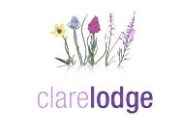

Management and Monitoring
Responsible Authority
Clare Lodge Secure Children’s Home is owned and managed by:
Children Services
Peterborough City Council
Sand Martin House
Bittern Way
Peterborough
PE2 8TY

Telephone: 01733 747474

Responsible Individual
Alison Bennett
Service Director, Safeguarding and Quality Assurance
Peterborough City Council
(Qualified Social Worker)

Registered Manager
Vacant

Team Manager
Jeanette Winson
Team Manager (Qualified Social Worker/Dip 5)

Kenny Christine
Team Manager (Qualified Social Worker/Dip 5)
Care Team
Cathy Gibson
Case Manager (Dip 5),

Laura Inns
Case Manager (Dip5)
Education Team
Rita Malton (QTLS)
Head Teacher

Business Team
Steve McFaden Business Strategy & Infrastructure Manager (CIPD, Level 3 & 4 CYP)
Debbie Lobley Business Support & Facilities Manager (CSBM)

Health Team (Cambridgeshire & Peterborough NHS Foundation Trust)
Simon Bamford Specialist Service Manager

Regulator
Ofsted,
Piccadilly Gate,
Store Street,
Manchester.
M1 2WD

Regulation 44
NYAS
Egerton House
Tower Road
Birkenhead
Wirral
Cheshire
CH41 1FN

Advocates
NYAS
Egerton House
Tower Road
Birkenhead
Wirral
Cheshire
CH41 1FN

Placement Referrals
Secure Welfare Coordination Unit
securewelfare@hants.gov.uk
Telephone 01962 846432

Overall Aims

Clare Lodge provides secure accommodation and support for young people who would be at or pose significant risk in any other type of accommodation, and who are subject to a Court order on “welfare” grounds in accordance with Section 25 of the Children Act 1989. In accordance with the young person’s needs and in the context of the Children Act 2004, The Children’s Homes (England Regulations 2015) and the Quality Standards.

Five principles underpin the general aims of the service:-

- The care and needs of the young people are the paramount consideration in any intervention.
- A commitment to anti discriminatory / oppressive practice and the challenging of discriminatory behaviour in all its forms.
- Full integration of services with individual placement plans to provide seamless provision to ‘wrap around’ the young person.
- Staff working in consultation with young people, their placing authority, parents and carers to formulate and deliver their placement plan in accordance with their overarching care plan.
- To provide qualified staff in all departments of the service who are valued, supported, and receive continued professional development in support of the service delivery.

The Regulations set out standards (“The Quality Standards”) which must be met by the Home. The Quality Standards describe outcomes that each young person is supported to achieve while resident at Clare Lodge. Each contains an over-arching, aspirational, child-focused outcome statement, followed by a non-exhaustive set of under-pinning, measurable requirements that Clare Lodge must achieve in meeting each standard.

The Regulations prescribe nine Quality Standards which must be met by the Home

- The quality and purpose of care standard (see regulation 6)
- The children’s views, wishes and feelings standard (see regulation 7)
- The education standard (see regulation 8)
- The enjoyment and achievement standard (see regulation 9)
- The health and well-being standard (see regulation 10)
- The positive relationships standard (see regulation 11)
- The child protection standard (see regulation 12)
- The leadership and management standard (see regulation 13)
- The care planning standard (see regulation 14)

Overall, the home aims to support and value the young people, through promoting dignity respect and trust. This is achieved through staff maintaining good supportive professional relationships. To act as good ‘parents’, listen, give advice, and act as advocates for them.

The aim is to support and work with the young people, through a behavioural support programme and a trauma informed approach. The purpose is to help the young people to understand their past experiences and their risk-taking behaviours, with the objective to help them manage their behaviours by learning coping strategies and identifying support structures. This is achieved through taking part in education, physical and mental health sessions, and activities. To help boost self-confidence regarding self, in relation to self-care and managing their own health and wellbeing. Preparing the young people to transition back into an open setting to continue the work that has been undertaken at the Home. Considering the criteria stated in Section 25 of the Children Act 1989:

The 'welfare' criteria are that:
- The child has a history of absconding and is likely to abscond from any other description of accommodation; and
- If the child absconds, (s)he is likely to suffer Significant Harm; or
- If the child is kept in any other description of accommodation (s)he is likely to injure her/himself or others.

Services and Facilities:

Clare Lodge can provide Secure Accommodation for up to 16 young people, with ages ranging from 10 to 17 years who are subject to a Court Order which authorises restriction of liberty for “welfare” reasons (S25 of the Children Act 1989). Welfare placements for children under 13 require Secretary of State approval.
In exceptional circumstances, the Registered Manager will consider continuing the accommodation of a resident beyond their 18th birthday for a time limited period (up to one month). This would be subject to all the appropriate legislation, court orders and local authority support. This is for a transition into an appropriate placement and must be in the best interest of the young person.

Clare Lodge has a long and proud history of working with young people and although able to respond to behaviours commonly presented by those placed in secure care, specialises in offering services to young women at risk as a result of self-harm, sexual exploitation, abuse, experiencing mental health issues and emotional difficulties.

The staff have experience and specialist training in dealing with child sexual exploitation, sexual abuse, trauma, emotional regulation, mental health attachment, safeguarding, self-harm and those who threaten suicide. The Home operates strategies which consider behaviours in the wider context and finds solutions that promote change using our multi-disciplinary team.
Clare Lodge offers a comprehensive assessment and evaluation service dependent upon the identified needs of the young person and the placement plan.

Young people are encouraged to become involved in the daily routine. Having clear expectations and routines allows the young people to feel a sense of belonging, and when expectations are met, a sense of achievement.

The services provided include: -

- A secure environment that supports young people in regulating their behaviour and rewards their efforts in trying to do this through building relationships, attending education, taking part in activities and the routines of the home.

- Young people are encouraged to reflect and work with professionals and care workers. This includes work to inform on future placements.

- Partnership working with all stakeholders to provide an experience which meets individual need and allows each young person to mature, and develop their personal identity.

- The provision of: -

- Catering services from our own kitchens, providing home cooked food.
- En-suite bedrooms
- Welcome bag which includes all bedding, and toiletries
- A range of review and assessment activity regarding identifying need, placement planning, and the management of risk.
  - A fulltime, individualised educational programme. Provided by qualified Teachers and Teaching Assistants.
  - Full assessment and support through the In Reach services provided by CPFT (Cambridgeshire and Peterborough Foundation Trust), contracted through NHS England. This includes on site:
    - Psychiatrist
    - Psychologists
    - Assistant Psychologist
    - Occupational Therapist
    - Physical Health Nursing
    - Mental Health Nursing
    - Speech and Language Therapists
  - Provision of Placement Plans which are overseen and implemented by the care team which include:
    - Team Managers/case managers – registered Social Workers and / or Diploma 5 in CYP (Children and Young People)
    - Team Leaders – Qualified to Diploma 4, with Diploma 5 (or working towards)
    - Residential Care Workers – Qualified to Diploma 4 (or working towards)
  - Group and individual work on a range of issues including bullying, anger management, sexual identity, sexual exploitation, equality and diversity and personal empowerment.
  - Behavioural support programme
  - Access to a range of media and learning which recognises diversity and supports cultural and faith needs.
  - A range of interventions and support to meet individual need including life story work, managing family contact and building self-esteem.

Accommodation

Home
The accommodation comprises of five main living/bedroom areas, known as lounges. Each lounge provides living facilities for up to four young people.

- Individual bedrooms with en-suite facilities.
- Digital television and communications systems, including facility to call approved contacts.
- Toilet and bathroom
- Washing and drying machines
- Kitchenette for washing up, including fridge and drink making facilities.

Sometimes, where it is appropriate and considered, children may need to live alone to support their wellbeing. At Clare Lodge, this can be facilitated across the lounges. In addition, there are also further facilities available to support individual, independent life skill programmes with the provision of cooking and kitchen facilities.

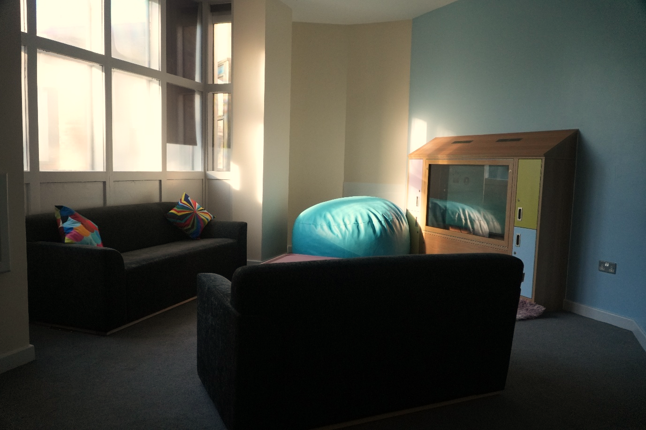

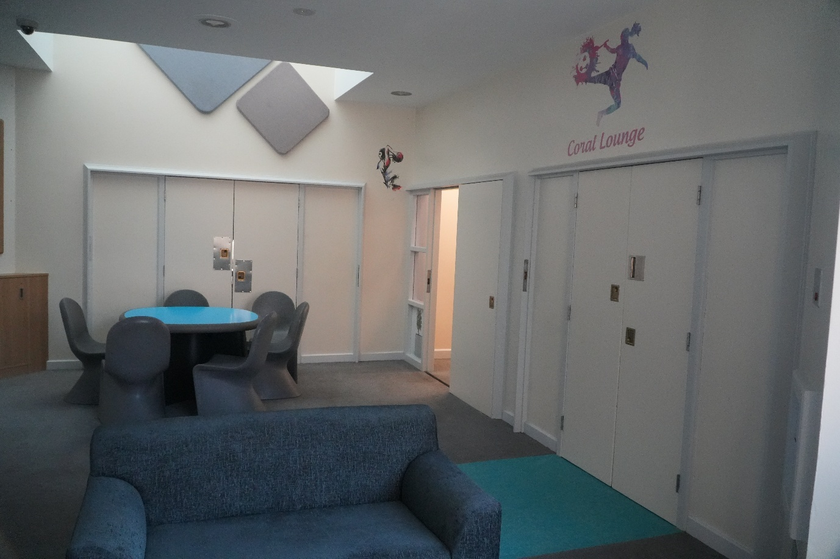

School
Young People attend education within the secure facility. The school provision comprises of classrooms and workshops which include a beauty salon, music room, food technology, and gymnasium and fitness suite.

Health
The Health Team work with the young people in various areas of the Home in addition they have use of:
- Bespoke medical room
- Sensory Room
- 1:1 consultation room

In support of the services there is a reception waiting area, toilet & kitchenette facilities for receiving visitors, including a visitor’s room. Visiting professionals attend meeting rooms and there is a training room provision in support of staff development.

Security is maintained within the building, and outside where there are three recreational areas contained within a secure perimeter.

- A garden area comprising of seating areas, planting and trim trail.
- Play Area with hopscotch and snakes and ladders.
- Sports Area with sports pitch and seating

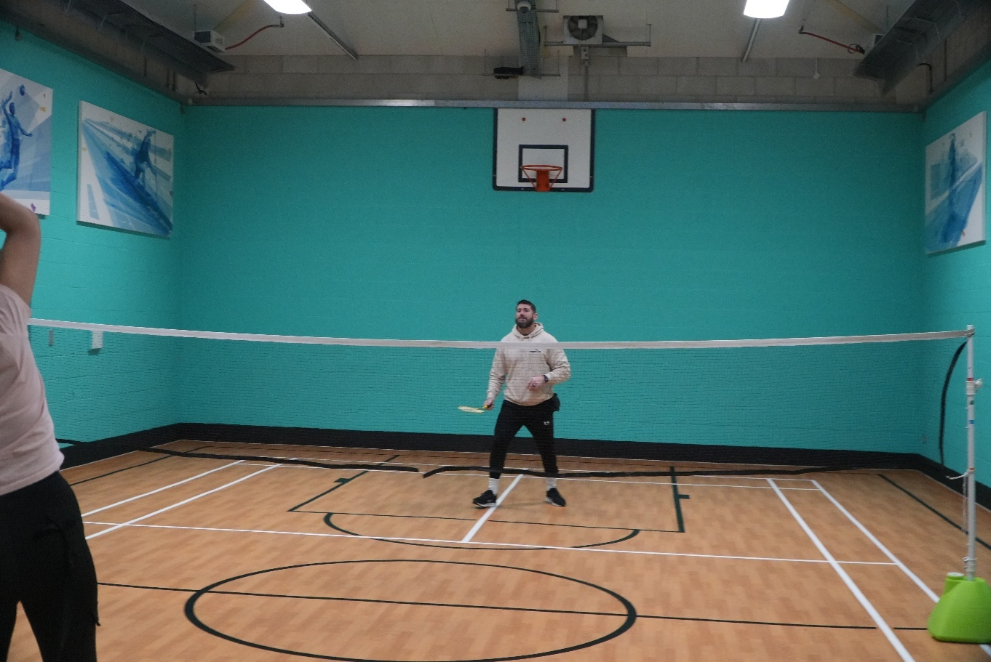

Staffing

Responsible Individual: Alison Bennett

Employed by Peterborough City Council. Service Director, Safeguarding and Quality Assurance. Alison has a Diploma in Social Work and has worked with Peterborough City Council since 2013 and has led on Quality Assurance across all Children’s social care domains.

Registered Manager:

Vacant.

Leadership Team

The leadership team are managers drawn from each team within the Home. Business, Care, Education, Health. They are qualified and experienced within their disciplines.

Residential Care Staff

The residential care staff team originate from a variety of backgrounds and experience. Team members have a wealth of childcare experience and training and are skilled in building and maintaining relationships with the young people. Staff are developed through regular training, and the expectation is to attain Diploma 4 in Children and Young People.

All Care and Education staff are CALM (Crisis, Aggression, Limitation, Management) trained and accredited, and all are required to attended a range of training courses relating to the care of young people.

Details of the experience and qualifications of all staff employed at the Home are available on request either to the Registered Manager of the Home, or to the Children’s Services, (Human Resources), Peterborough City Council, Bittern Way, Peterborough, PE2 8TY.

The Organisational Structure of the Home

The organisation of the Home follows a structure of accountability.

The Responsible Individual manages the Registered Manager who in turn manages the Head Teacher, Business Strategy and Infrastructure Manager and the Care Managers. (See appendix 1). From this, the structure departmentalises based on roles within the team.

The school structure consists of the Head Teacher, Teachers, and Teaching Assistants. The Head Teacher is responsible for the provision of education on site. Additional professional support to the Head Teacher is via School Improvement Partner (SIP).

The business team consists of the Business Strategy and Infrastructure Manager, a Business Support and Facilities Manager, and a full business support team incorporating Finance, Catering, Housekeeping, Maintenance and administration staff.

Team Manager/Case Manager takes responsibility for young people and a staff team. They case manage the young people whilst they are placed here. In addition, they are responsible for the supervision of care staff who work with them. Individual Team Managers also have responsibilities for leading on safeguarding and induction, training, and development of care staff.

Night care staff are employed at the Home to maintain a waking presence to respond to and monitor the needs of the young people throughout the night. There is a Team Leader on nights who takes responsibility for the supervision and on-going support of the night staff. Night staff also respond to callers at the Home and take responsibility for site security during the night.

If required night staff may call upon sleeping-in day staff for assistance, who in turn are supported 24 hours a day by a named Duty Manager.

Care Staffing Levels

The staffing levels will reflect the level of risk and the daily needs of the young people.
Care staff ratios are assessed around the needs of the safe environment for the young people and will be on duty in the lounges and for activities during the day, supported by a shift coordinator and duty manager. During the day ratios of staffing to young people can range from a minimum of 1:1 or 2:4.

During the nighttime, young people are supported with a minimum of 3 waking night staff, a residential worker sleeping in and an on call duty manager.

For mobility outside the Secure Home, up to 2 or 3 staff to 1 young person may be required, according to an assessed level of risk. Transition visits are often 2 staff to 1 young person. Health appointments can be 2 or 3 to 1, in accordance with assessed risk.

Whilst the staffing ratios are set out above. Due to the increasingly complex needs of some of the young people referred to the Home, the staffing levels can be higher. This is continually assessed by the Care Management Team in agreement with the referring Local Authority.

Young people live within “lounge” groups of up to four and have contact with other lounge groups subject to risk assessment, and usually for a specific purpose or activity. These arrangements help counter the more negative risks associated with the management of large groups, multiple placements from the same Local Authority, or young people who know each other (where the relationship may have a negative impact).

Meetings:

A range of meetings take place across the Home for staff to improve communication and support the delivery of the service, they include:

- Changeover Meetings
- Management Daily Discussions Meetings
- Care Planning Update Meeting
- Senior Leadership Team Meetings
- Staff Meetings inc. staff support and departmental meetings across the services
- Team Leader Meeting
- Medication Management
- Incident Review Management Meeting
- Wellbeing and Participation Group

In support of the young people and meeting Statutory Requirements, the following meetings are accommodated at the Home:

- Placement Planning
- Initial Formulation
- Secure Accommodation Review (SAR)
- Reformulation Meeting (Health)
- Looked After Children (LAC) Review
- Transition
- Professionals
- Personal Education Plan (PEP)

The organisation and running of the Home are further guided by a range of written policy and procedural information which is available to all staff.

Each young person at the home has an electronic and paper file which contains information relating to behaviour, appointments, details of health, education, and contact with the field Social Worker, family, and others. All staff read the logbook and case recordings when they have not been on duty at the Home. Reading these notes also supports continuity and planning.

Arrangements for supervision and staff training

All staff receive regular formal supervision and appraisals in line with regulatory, departmental and employer requirements. The staff are encouraged to develop skills through a comprehensive range of training made available from within Clare Lodge and Peterborough City Council.

The training offered to care staff is compatible with Diploma requirements. New care staff undergo a comprehensive induction programme, and shadowing experience, followed by a range of other learning opportunities.

The care staff rota is designed with a two hour overlap to provide opportunity for supervision, bespoke training sessions, debriefs and support.

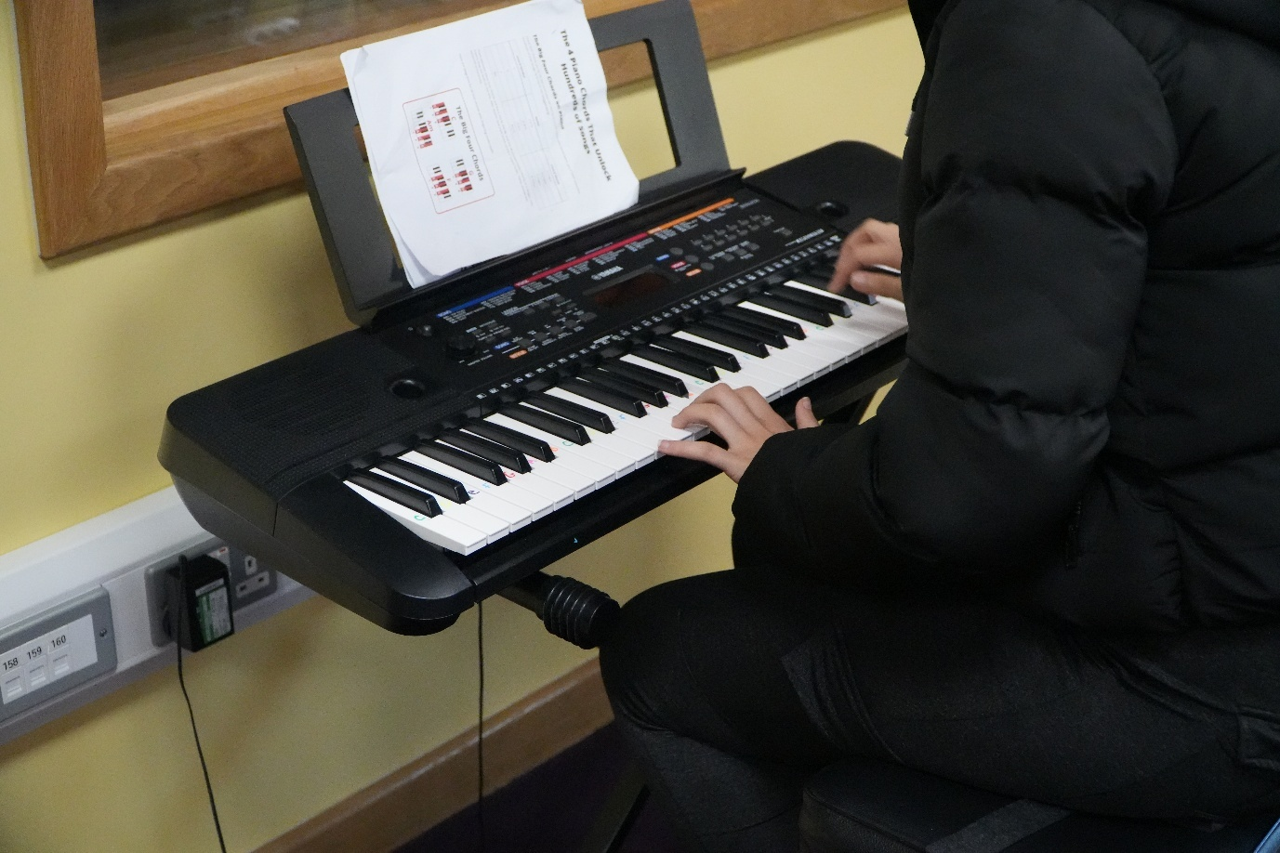

Criteria for Admission and Referral Process

Clare Lodge is licensed by the Department for Education to provide secure accommodation for up to sixteen young people between 10 years to 17 years. In order to provide a placement, the Home must also receive a copy of any authorisation, or the Court Order in respect of the young person at the time they are placed.

Referrals are sent to the Home from the Secure Welfare Coordination Unit. These are reviewed by a multidisciplinary team led by the Registered Manager.

A review of referral documentation and communication with the referring authority allows the team to assess the prospective young person’s suitability to be placed at Clare Lodge. Consideration is given to the current client group and the impact the referral may have if placed.

Overall, the Home provides a safe environment that supports young people with complex needs including, exploitation, physical and sexual abuse or inappropriate life experiences.

Admission to Secure Children’s Homes is strictly regulated by law. Clare Lodge provides accommodation on Welfare Criteria, under Section 25 of the Children Act 1989 which specifies the criteria. This must apply before a young person may have their liberty restricted.

A child who is being looked after by a local authority may not be placed in accommodation restricting liberty (secure accommodation) unless it appears that:

- They have a history of absconding and likely to abscond from any other description of accommodation: and
- If the young person absconds, are likely to suffer significant harm

Or

If kept in any other description of accommodation, they are likely to injure themselves or other persons.

Admission

Young people being admitted to a secure facility are often anxious and frightened. To help support and reduce their anxiety there is an expectation that young people are informed of the reasons for the decision to place them in secure accommodation, this should include what to expect on admission.

On arrival, staff will welcome the young person and go through the admission process which is as child friendly as possible. It may be necessary for the young person to be searched. Searches are risk led. Clothing will be searched but no intrusive body searches will be carried out, although young people may be kept separated and asked to hand over items hidden in their bodies if there is good reason to suspect that they have concealed something. Items not permitted in the Home will be secured in the possession store or returned to the Social Worker.

New arrivals will be introduced to staff members and other young people placed in their assigned lounge. If possible and risk allows, they will be given a tour of the Home to help them settle. If key workers for the young person are not undertaking the admission process, they will be introduced to them at the earliest possible opportunity.

Young people will be shown their bedroom and the facilities provided within the room. All bedrooms have been deep cleaned and, if necessary, re-painted. Along with this, new bedding and towels have been provided, there is also a cuddly toy, new toiletries, a colouring book and a welcome booklet.

Young people will be encouraged to ring their families as soon as possible after admission if appropriate.

Young people are provided with a clothing allowance to supplement their existing clothes, and this is to buy appropriate clothing. In addition to this, young people receive pocket and toiletry money.

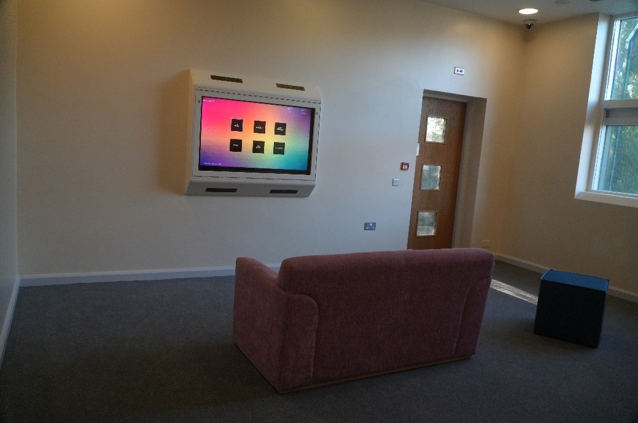

Education

Clare Lodge believes that education is a fundamental right for every young person placed. Setting a good foundation through education is one of the most important contributions the Home can make to a young person’s future, and we aim to provide a school where young people feel happy, safe and cared for and where they are given the opportunity and confidence to discover and achieve.

For many, Clare Lodge provides their first positive education experience. The ethos of the school is to build on this and give pupils a sense of being successful and valued, so they in turn can enjoy and value education. It is hoped young people can take this experience forward into new school settings and continue to enjoy success and achievement. Many of our young people have not attended school for many years. Our aim is that all students leave Clare Lodge with nationally recognised qualifications at an appropriate level.
The education team comprises of a Head teacher, qualified teachers, SENCO and teaching assistants. Teaching groups comprise of up to four young people taught by a teacher and supported by a teaching assistant. Attending Education is non optional regardless of age.

Subjects covered: English, mathematics, ICT, physical education, PSHE, child development, biology, geography, cookery, hair and beauty, art, life skills, music and careers guidance. We also work closely with health colleagues to support with the PSHE curriculum.

Young people at Clare Lodge can gain a variety of qualifications, as appropriate. Current accreditation includes functional skills in English, mathematics and ICT (Entry Level 1 – Level 2); Food Hygiene Certificate; AQAs, BTECS; in Sport, Health and Social care, Hospitality and tourism, Digital media, Business, Hair and Beauty and IT.
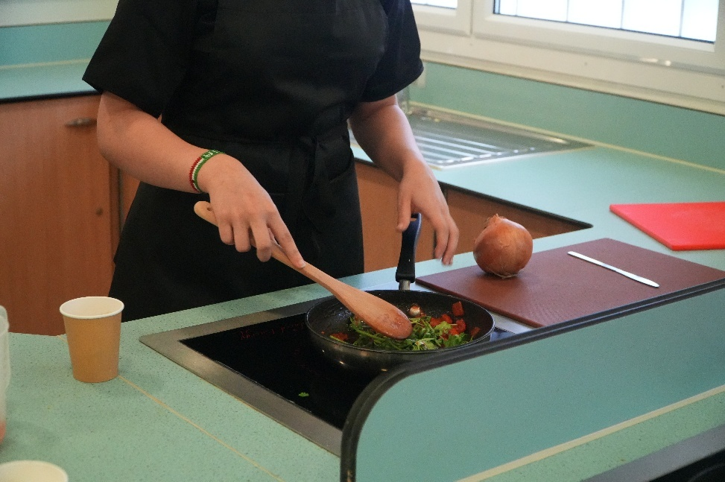

All pupils at Clare Lodge have varied and exceptional needs. We consider differing needs and plan an individualised curriculum, looking at each student's starting points, and the different strategies needed to meet those needs.

Some students enter Clare Lodge with an EHCP, we will arrange reviews of EHCP's during their stay at Clare Lodge. For those without an EHCP, we will consider raising a request for statutory assessment. The Designated Teacher has oversight of all young people’s Personal Education Plan’s (PEP) and ensures that all meetings are attended, and progress is shared. We work with the local authority to meet the PEP national guidelines.

It is very important that the progress a young person makes at Clare Lodge can be built upon in the future, and to this end we will provide detailed reports to local authorities, education departments and future educational placements. We liaise closely with Local Education Authorities (LEA’s) to both gather initial information and share information when a young person leaves us.

Homework maybe given during term time, relevant to their studies in school, and completed at times set aside for this purpose during the early evening. Young people may, and often do, elect to do extra private study in the evenings.

After school clubs are run by teaching staff twice per week.

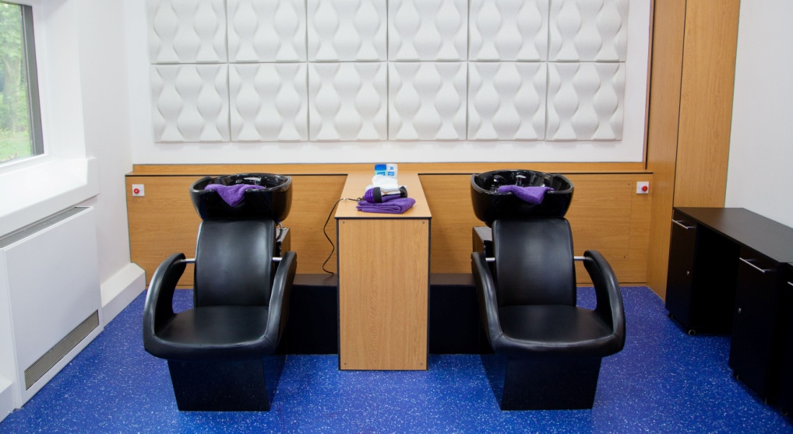

Health Arrangements:

Clare Lodge takes a positive approach to each young person’s health, including general observation, health care assessments, monitoring developmental progress, and the treatment of illness and accidents. The in-reach health team is provided by Cambridge and Peterborough NHS Foundation Trust (CPFT).

All young people receive an initial health assessment using the Comprehensive Health Assessment Tool (CHAT). This includes physical and mental health, sexual health, substance misuse assessment and a neuro-disability assessment within a 10-day period from admission. This is then reviewed regularly every 3 months. All young people have a named health care lead who is responsible for the co-ordination and delivery of the individual care programme.

The In Reach service provides the Home with:

- Physical health nurses and mental health nurses, who hold regular clinics and ensure the young people’s health care plans are on track.
- A psychologist, assistant psychologists, a psychiatrist, and occupational therapist and assistant also support the young people.
- Access to an immunisation nurse is arranged through the health team as required.

Together they contribute to the evaluation and therapeutic treatment of the young people and assist staff through the provision of learning and support strategies. The Home has an inclusive approach to care practice.

All young people are registered at a local GP practice by the Home.

Drug and Alcohol interventions take place with health and care staff. We do not have a detox facility.

Young people have access to attend both dental and optician services. Similarly, visits to specialist hospital out-patients’ appointments are arranged and facilitated as required.

Care and education staff are trained in administering First Aid and will do so if minor problems arise.

Subject to risk assessment, young people can also attend dental treatment which is available locally within the community.

The Home also has an Art Therapist who runs groups and individual sessions.

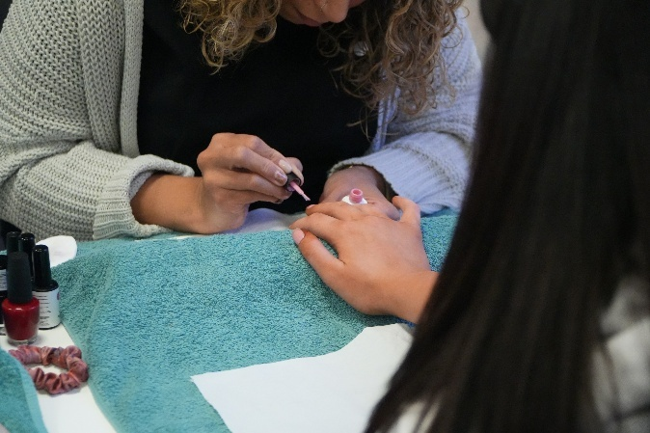

Staff keep parents and those with parental responsibility informed at all times of changes in each young person’s health. However, if a young person wishes information to remain confidential, this is respected.

Whilst staff encourage young people to access medical services when they feel unwell, legally those aged 16 and over can give, or withhold their consent to treatment. Young people under 16 may also be able to give consent, depending on their capacity to understand the nature of the treatment. Legally, it is for the doctor to decide whether the young person is capable of giving informed consent. Young people who are capable of giving consent cannot be medically examined and treated without their consent. A signed medical consent form will be required for young persons under the age of 16.

Young people are encouraged to take care of themselves in terms of nutrition and lifestyle, to be aware of symptoms, and when required to seek professional medical treatment.

Care Staff are trained in medication administration. Medication is stored in the medical room in appropriate secure cabinets accordingly. The storage and administration of medication is conducted securely in accordance with the regulatory requirements and is fully recorded to safeguard against the possibility of confusion or abuse. The medication administration is monitored and audited jointly with the health team nurse.

When hospitalisation is required two members of staff will accompany the young people requiring hospital treatment, with additional staff being deployed as necessary. If any extended periods of hospitalisation (more than 24 hours) are required and where additional staff are needed, the Home will arrange this in cooperation with the referring local authority.

Recreational, sporting, and cultural activities

Clare Lodge offers a range of opportunities for young people to engage themselves in recreational and sporting activities. The Home has a gymnasium, fitness suite and outdoor recreational areas.

Young people are provided with information on maintaining a healthy lifestyle by staff and through the education and health programmes offered by the Home.

A range of activities are available – including bouncy castle, keep fit, visiting craft / activity co-ordinators, football coaching and karaoke in addition to a range of arts and crafts, hair and beauty sessions.

The Youth Dreams Project (YDP) attend Clare Lodge to promote and supply specialist sport sessions. We work closely with external agencies to provide support to young people and link with:
- Animal experience zoo, who bring animals in for young people to see, hold and touch.
- Big Foot Leisure- Bouncy Castle Activities
- Creative Arts- Holly
- Kinetic Youth- Activities Friday and Saturdays or Saturdays and Sundays Alternating.

The resident activities team also devise a programme of activities during the school holidays.

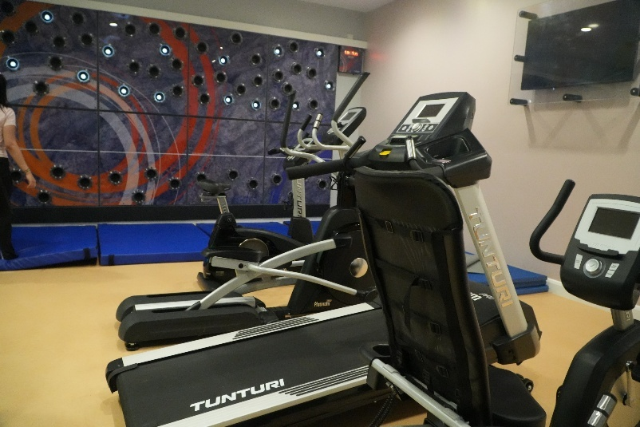

Planned mobility programmes are put in place with care staff accompanying the young person, outside of the secure facility. Mobility’s are agreed with the placing authority and take place after a period of being at Clare Lodge and subject to risk. The range of mobility’s cover educational, life skills and recreational.

A range of non-stereotypical multicultural media is available/on display within the Home. Major festivals, e.g. Diwali are celebrated/marked by discussion and/or the preparation of particular foodstuffs.

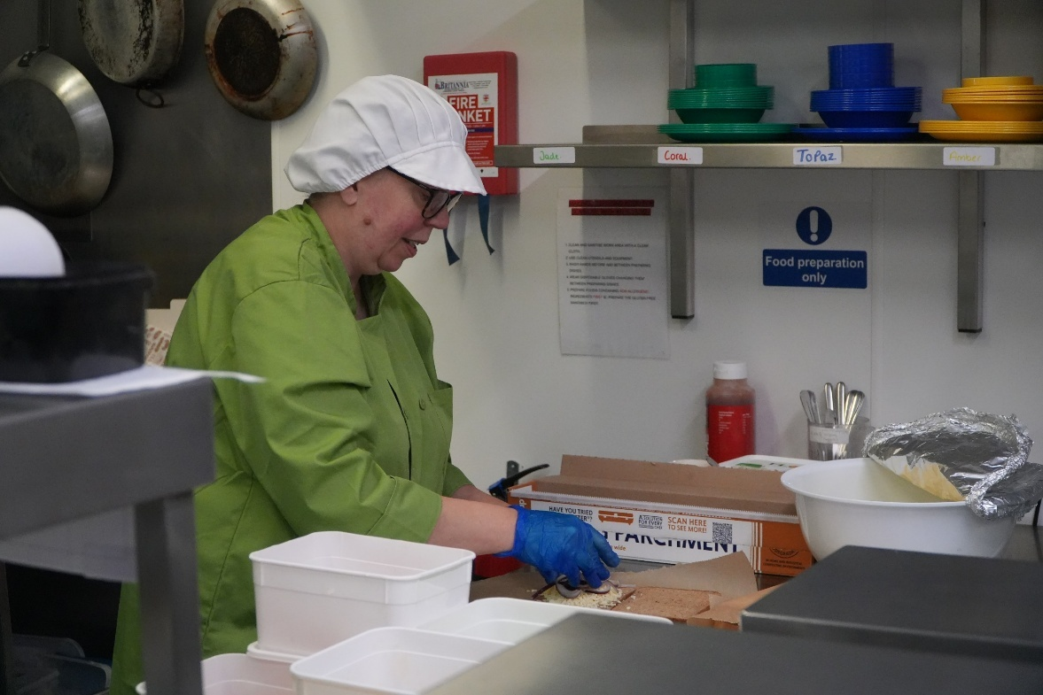

Behaviour Support

The behaviour support programme is to help young people regulate their own behaviour and be rewarded for the efforts they make in trying to do this through building relationships, attending education, taking part in activities and the routines of the home. This is done in a supportive, nurturing and trauma informed way.

Clare Lodge has a therapeutic approach and we work in line with the Attachment, Self-Regulation and Competency Treatment Framework (ARC). Whether the young person receives interventions through Education staff, Health staff, Care staff or any partnerships groups, all are delivered under the therapeutic model.

Good professional relationships between staff and young people are encouraged and young people are expected to take responsibility and show respect for the home, assisting it to run smoothly through acceptable behaviour and consideration for others.

Some young people initially have difficulty in responding to expectations and are encouraged to discuss these difficulties with staff who allow them to explore their feelings and find more positive ways of expressing themselves. Much of the approach is concerned with commonsense, good parenting, negotiation, and compromise. There is an emphasis and expectation on staying safe and managing risk taking.

Whilst the emphasis is on promoting positive behaviour, in situations where young people continually fail to respond, staff will become more directive. If young people endanger themselves, others, or cause serious damage to the fabric of the building, staff may also need to intervene physically. All staff are trained to physically intervene safely using a BILD accredited non-pain compliant system called CALM®.

The home has clear written policies on maintaining good order which set out the actions it is permissible for staff to take. This document is available upon request.

Young people/staff are expected to respect each other. Respect in this context means valuing each other by speaking and behaving with other people in an appropriate way. This includes not using obscene, offensive, racist, or sexist language, not engaging in bullying behaviour, and respecting and valuing diversity.

Similarly, young people are expected to look after the building, furnishings, and fittings. Deliberate damage or graffiti affects everybody and wastes money that could be better spent on other things. It is to everybody's advantage that the Home looks good and feels comfortable.

Clare Lodge operates a trauma informed behavioural support programme. This is designed to encourage young people to reach their targets and goals through positive interactions with staff using a reflective and restorative approach. This supports young people to demonstrate and internalise the benefits of appropriate behaviour. The home operates a three-level risk system that determines what young people can do when on a certain risk level. This includes what activity areas of the building they can use and if they can go on mobility.

Details of physical restraints and single separation are reported to the duty manager, and are also fully recorded.

All risk management decisions are appropriate / proportional to the behaviour and are of limited determinate time. Care staff are guided and trained in regard to Children’s Homes Regulations and Quality Standards.

All records of permissible forms of control are subject to frequent checking by a range of regulatory and statutory bodies.

The regulations permit action which: -

- Protects and promotes the health of the young person including following lawful instructions of a registered medical or dental practitioner.
- The taking of any action immediately necessary to prevent injury to any person or damage to the property.

- The imposition of a request that a young person wears distinctive clothing for purposes connected with her education.

Child Protection and Safeguarding

Copies of the Peterborough Safeguarding Children’s Partnership Procedures are available to all staff, and / or on request.

Peterborough City Council Safer Recruitment procedures are followed for all staff employed at the home. All staff are subject to enhanced checks via the Disclosure and Barring Service (DBS), and references from previous employers. Evidence checked regards qualifications. Managers undertake periodic dip samples on recruitment activities to ensure compliance.

Staff receive an induction which includes Child Protection training with regular retraining / updates (3 yearly). Staff are also provided with an e-learning resource yearly, should they wish to refresh knowledge. Staff are familiar with the safeguarding procedures, are competent in preventing and identifying abuse, and in responding to disclosures or suspicions of abuse.

The principles of the Home’s approach to child protection are: -

- Young people have the right to receive protection from all forms of abuse and are given support which is reassuring and informative.
- Anyone may raise concerns about the possible abuse of young people, and that all concerns raised are taken seriously, investigated, and dealt with sensitively.
- Investigations and support offered are cognisant of the wishes of the young person and takes account of their age and understanding, race, gender, sexual orientation and disability. Thereafter, young people are kept informed of the process and progress of the investigation.
- Information is shared and that all investigations incorporate an independent element.
- The investigation process does not prejudice the right of the young person to pursue their concern / allegation through other channels e.g. directly to the police.
Through training and access to Peterborough’s safeguarding procedures staff are aware of the procedures to follow should they receive allegations, observe or suspect behaviour/practices that are not in the best interest of the young people. Staff are aware of the procedures should they receive an allegation.

When a concern is raised, it is reported to the Registered Manager, via the Designated Safeguarding Lead, who determines the action to be taken, ensuring the safeguarding procedures are followed. The safeguarding lead for the Home with liaise with the LADO for advice where necessary.

The infrastructure of the Home such as CCTV, door access and observation panel systems assist in monitoring the safety of children and staff and are used to support investigations of complaints and allegations.

All restraint incidents are reviewed using CCTV footage. Any concerns will be reported to the Registered Manager and Safeguarding Lead. If concerns are identified, they will make referral to the Local Authority Designated Officer (LADO) who has agreed this protocol.

Bullying

High levels of observation by staff help to counter bully but it is recognised that where there are groups of children/young people, attempted bullying is inevitable.

Young people are encouraged to inform staff if they feel bullied or intimidated by others. The Home views bullying as anti-social behaviour which causes distress to an individual or group, is motivated by the desire to hurt, threaten or frighten through the abuse of power manifested in threats, verbal taunts, abuse of possessions, theft, and physical violence. All bullying is taken seriously at the Home and is investigated.

All young people are offered guidance and support regarding dealing with bullying from both the perspective of those being assaulted, and those committing these acts. To help counter bullying, young people do not have access to each other’s bedrooms.

Unauthorised Absence

Should a young person abscond, the police, parents, social worker and responsible Individual will be notified immediately of any unauthorised absence.

Each incident is also notifiable to the licensing authority Ofsted who act on behalf of the Department of Education. There is an agreed protocol between the unit and the police, and this is displayed prominently in the duty room.

The Local Safeguarding Children’s Partnership have a ‘Missing from Care Protocol’ but in the event of a young person being missing there would be a liaison between the Local Safeguarding Children’s Partnership and the relevant Authority’s Safeguarding Board. An information form is available for the police to use in order to conduct their enquiries, if a young person goes missing.

Work will be done when the young person arrives back at the Home, the management will review the incident to determine any lessons that could be learnt and the risk assessment for the young person will be revised.

Security & Surveillance

Staff working directly with young people wear a pager type alarm which can be activated if assistance is required. The exterior and interior of the Home and school is also monitored by CCTV cameras, which can be viewed in the Duty Room. In respect of privacy and dignity the young people’s bedrooms and bathroom areas are not covered by the CCTV system.

CCTV footage covering physical interventions, incidents, allegations, and security breaches are reviewed to inform learning and improve practice.

The CCTV policy is available on request for more information.

The Home has a locking system in place, these monitor entrances and exits in most parts of the building. Generally, young people cannot pass from area to area without staff assistance. However, for suitably risk assessed young people, the lounge doors leading to the bedroom area can be secured to allow free access within this small area for a limited period.

Entrance to the Home is via a series of locked doors. Staff keys and fobs are subject to biometric fingerprint identification and have a separate entrance from visitors once through the main entrance.

The communication system allows young people to talk to staff when they are in their rooms. This is also monitored from the Duty Room and through the pager alarm system.

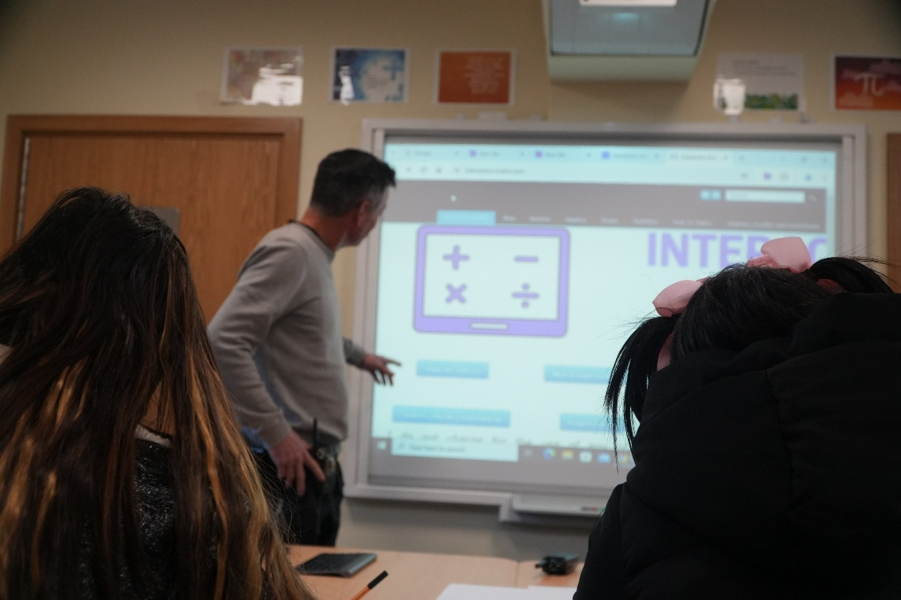

Fire Precautions / Emergency Contingency

The Home has numerous design features to contain fire and has a fire certificate. The risk of fire is kept under constant review.

All staff are aware of the fire procedures – new staff being made aware as part of the induction process. All young people and visitors are informed of the fire procedure on entry to the Home.

Fire alarm points, emergency lighting and fire drills are carried out in accordance with guidance from the local Fire Officer and within regulatory time scales. The system is regularly tested and maintained. All tests are recorded in the Fire Logbook.

A copy of the Fire Procedure relating to Clare Lodge is available upon request.

A contingency plan has been produced jointly with the Police which covers site evacuations and other emergency situations. This document is reviewed regularly and contains a range of risk assessments for different scenarios.

Cultural diversity and religious observance

The young people admitted here are from all over England and Wales and occasionally from outside the UK and therefore represent a diverse group from different cultures.

The Home will respect and, if appropriate, celebrate religious festivals or dates, including those on the Christian calendar.

At all times staff are cognisant of the various religious / cultural needs of the young people including specific dietary or personal requirements. Staff will endeavour to encourage the continuity of existing religious customs and observances, subject to the wishes of the individual.

As may be required, and subject to risk assessment, Clare Lodge is able to accompany young people to attend religious services, or to receive religious instruction within the Home.

Key religious texts, prayer mats, etc. are supplied for use by young people as and when required. Books such as the Bible and the Qur'an are available.

The young people are encouraged to learn about other religions and festivals, not just through education but by the staging of events and activities at the appropriate times.

The council also has a chaplain that can be called upon if needed.

Contact

The local authority has a duty to promote and maintain contact between the young person and those connected with her, unless the contrary is specified by order of the Court.

Clare Lodge encourages young people to maintain contact by letter, video calling, and telephone with their families where this is appropriate. All contact arrangements are agreed at the admission stage and are reviewed regularly or when there is a change notified by the referring local authority/court. Communication can be facilitated with support from staff in order to maintain safety.

Contact takes place in a private visitor’s room, though meetings may have differing levels of staff supervision depending upon the particular circumstances of the individual young person. Supervision requirements in this regard are discussed in the young people’s meetings. The prohibited Items list is prominent on the reception desk for visitors to see and sign to agree to.

Parents and those with parental responsibility are invited to attend all meetings regarding their child held at Clare Lodge.

Allocated social workers are expected to have contact with each young person placed at least once monthly.

Arrangements exist for the provision of interpreter, and translation services, including the production of media in a range of languages as required by young people and/or parents for whom English is not their first language.



Complaints and Representations

Relationships with staff are based upon mutual trust and respect. Young people may raise concerns they have at any time and may choose to do this in private with any person employed at the home. All matters raised are taken seriously with every effort being made to resolve and reach agreement with the young person. All young people are made aware of how to raise concerns, access NYAS advocates, or to complain formally.

Attempts are made to resolve concerns as close to the point of origin as possible. In the first instance therefore, complaints should be made to staff at the Home. Should matters not be resolved to the satisfaction of the complainant, the matter can be raised with the Registered Manager responsible for the Home (contact details are given within the useful addresses page near the start of this booklet). If the complainant remains dissatisfied a formal complaint may be made to the Peterborough City Council Customer Care Section (01733 747474), to NYAS, or to the placing Authority. Ultimately, if still not resolved, the complainant may approach Ofsted.

Within the Home, young people have access to a confidential complaints system through which they may raise issues. Members of the management team respond to each matter raised promptly.

Within the bedrooms young people have access to a telephone system. These have pre-programmed numbers NYAS & Child Line. This means young people can facilitate calls to these organisations without going through staff.

On admission to Clare Lodge, all young people are given information (within the Young Person’s Handbook) about how to comment on or complain about the care they are receiving, including a leaflet on the Complaints Procedure and a freepost envelope addressed to the independent advocacy service. Placing Social Workers are also informed of all complaints made.

Exit interviews / questionnaires are also used to gain views at the end of each placement from both the young person and placing Authority.

Statutory Reviews and Meetings

Section 26 of the 1989 Children Act requires the regular review of written Care Plans relating to each young person ‘looked after’ by them.

The purpose of the review is to ensure each young person’s welfare is safeguarded and promoted in the most effective way during the period she remains ‘looked after’. The Review of Children’s Cases Regulations 1991 specifies that the first review must be held no later than 4 weeks after the young person begins to be ‘looked after’. The second review must take place no later than 3 months after the date of the first review. Subsequent reviews must take place at intervals of no more than 6 months after the date of the previous review.

The timing of the review will not necessarily coincide with the date of the young person’s admission to the Home; i.e. the date of the review being dependent on the date the young person began to be ‘looked after’, rather than the date they were admitted to the Home (although in some cases this will be the same).

The frequency laid down by law is a minimum requirement. A review can be triggered by any party should the individual circumstances deem this necessary.
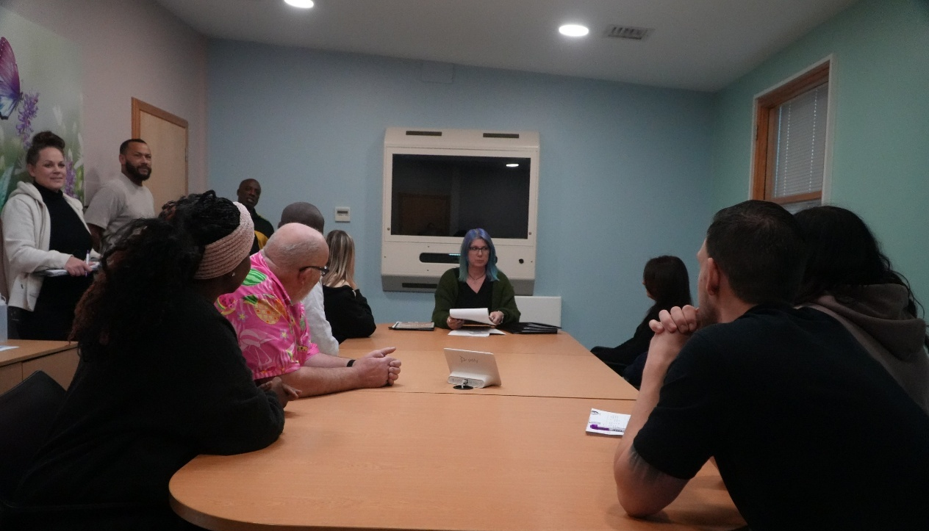

With sufficient notice, Clare Lodge will happily provide a venue and other resources for meetings, even though reviews are the responsibility of the placing authority to arrange. Arrangements should be made with the chair of the secure accommodation review (SAR) meeting. Often it is sensible to combine SAR meetings with Looked After Children (LAC) statutory childcare reviews for practical reasons and consistency. We can accommodate these ‘virtually’ through conference calling, Zoom or Teams apps if required.

Regulations 15 and 16 of the Children’s (Secure Accommodation) Regulations 1991 are concerned with the review requirements for young people placed in Secure Accommodation. Regulation 15 requires the placing Authority to review the placement of any young person in Secure Accommodation within one month of the start of placement and, thereafter, at intervals not exceeding three months. This review is in addition to that required under Section 26 of the Act.

Regulation 16(1) specifies that those appointed to review the case must satisfy themselves that: -

a] the criteria for keeping the young person in Secure accommodation in a community home continue to apply, and

b] Such a placement continues to be necessary, and whether or not any other description of accommodation would be appropriate. In doing so, they must have regard to the young person’s welfare.

Each Local Authority is required to appoint three persons to undertake such reviews, one of whom must neither be employed by, or be an Elected Officer of the placing Authority, or by the Local Authority managing the Home in which he/she is accommodated. Staff from “NYAS” may assist in providing the independent person for this panel.

Responsibility for undertaking such reviews rests solely with the Local Authority ‘looking after’ the young person and not with the Home accommodating her. This must take place at Clare Lodge, allowing both the young person and key-worker to attend and contribute.

Some Local Authorities choose as a matter of expediency to hold criteria reviews away from Clare Lodge thereby depriving the young person/advocate, and others of the opportunity to contribute. Whilst such arrangements may comply with the letter of the regulations, in the view of Clare Lodge, they do not meet the “spirit” of the legislation as they deprive the young person of their right to directly, or with independent support, put across their view. Should the Criteria meeting be held away from the Home, written notes together with outcomes of the meeting must be supplied to the Home within the prescribed review timeframe. However, this rarely occurs with all meetings being held at the home except in extreme circumstances such as poor weather conditions.

Planning meetings are held regularly to ensure that work is being undertaken and to inform the placing Authority on the progress of the young person. The expectation is that all work is completed within the timescale agreed at strategy meetings. Copies of meeting notes are sent to placing authorities and provide an ongoing summary of placement progress. In addition, keyworker, and assessment reports are presented at planning meetings in accordance with the care plan. Health and education also contribute to these meetings.

Clare Lodge do not normally provide Court reports unless specifically requested. All written information is provided to the placing authority and may be quoted, or otherwise used to inform decision making, including applications to the Court.

Written information is supplemented by regular verbal reports as may be required.

Parents, carers, and other professionals attend strategy meetings which are chaired by the Case Manager. The young person also attends accompanied by the keyworker acting as advocate, and to report progress.

The planning meeting should not be confused with the Secure Accommodation Review or the Statutory Child Care Review. The planning meeting is the forum for case planning within Clare Lodge.

Details of Therapeutic Techniques

In theoretical terms the Home largely follows a behavioural philosophy in which positive behaviour is actively encouraged, promoted, and rewarded. Alongside this we follow the ARC framework (attachment, self- regulation and competency. The ARC framework is a flexible, components-based intervention developed for children and adolescents who have experienced complex trauma, along with their caregiving systems. ARC’s foundation is built upon four key areas of study: normative childhood development, traumatic stress, attachment, and risk and resilience. Drawing from these areas, ARC identifies important childhood skills and competencies which are routinely shown to be negatively affected by traumatic stress and by attachment disruptions, and which – when addressed – predict resilient outcome. Within this approach, the Home offers a range of interventions subject to the needs of the young person, and assessments undertaken.

There is a working group to ensure that care and education staff are working in an integrated way with the psychiatric/psychological staff as well as the other professional therapists and counsellors. Where possible, therapeutic interventions are delivered across the multi-disciplinary team so the young people have a range of approaches including educational, social and health interventions.

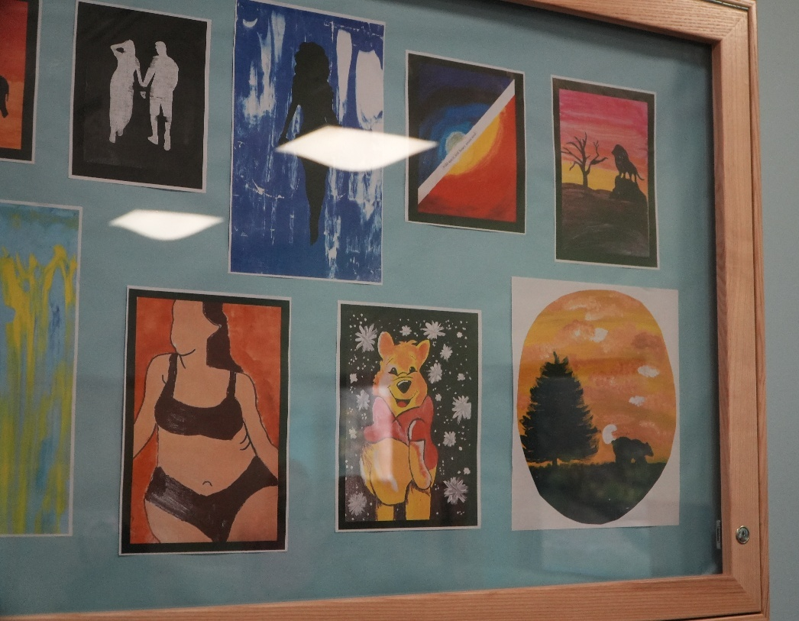

Anti-Discriminatory Practice

Everyone within the Home is expected to challenge discriminatory behaviour in all its forms. This may include sexual, and racial stereotyping, and devaluing other people because of ill-founded personal beliefs, or impairment.

Within Clare Lodge, all young people are treated with dignity and respect, and as individuals with the potential to overcome presenting difficulties and flourish. Many of the young people have suffered discrimination in the past, and accordingly the services provided are designed to individually restore a sense of worth and self- esteem.

All staff will be asked to demonstrate an understanding of anti discriminatory and oppressive practice at interview and during mandatory training. The staff at the Home do not tolerate and will challenge discriminatory language, attitudes, or offensive material, and put considerable effort into maintaining an environment which recognises, values, and promotes diversity.

Staff and young people alike are actively encouraged to report incidences of discrimination. It is important that a witness or a victim of discrimination reports the incident to the coordinator or the duty manager. The actions that will be taken if you were the victim of a discriminatory incident are that the duty manager will speak to the victim of discrimination on the day that it is reported. Space and opportunity will be given for the victim/witness to share how it made them feel and discuss further actions and any support they might need. A week later, a manager or a member of the health team will arrange to meet with the victim/witness so they can ask for further support (should they request it) or talk about the impact of the incident further, should they wish to.

Young people observe and model their behaviour on that of the staff who are always expected to promote, demonstrate, and reflect the commitment of the Home to fair and non-discriminatory behaviour - in practice: -

- Everyone within the Home is expected to show respect to others, to listen, treat colleagues and young people in a way they would wish to be treated, and to challenge negative statements and attitudes.
- To take into consideration the cultural and practical needs of minority ethnic staff, parents, and young people in relation to language
(Including access to information in their first language), food, clothing, and religion so as to ensure equity, and equality of opportunity for all.
- To recognise and celebrate and endeavour to understand different values and beliefs.

How to Find Clare Lodge:
Clare Lodge

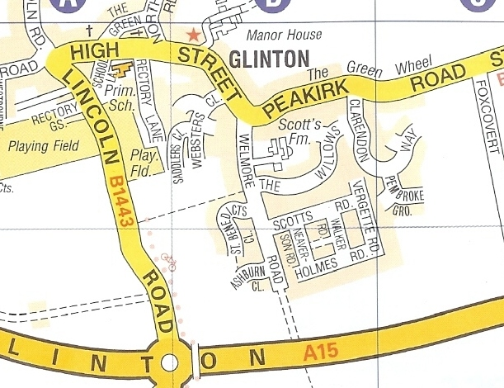

Rail:

There is a regular train service from London Kings Cross for visitors from the south and a number of excellent services from the north and other areas of the country.

Road:

The A1 passes Peterborough and gives easy access to the city. Travelling from the Midlands there are a number of options including the A47 and the A427. Glinton is just off the A15 Lincoln Road leaving Peterborough. If you approach from the North come through Northborough, through the traffic calming into Glinton and out towards the city centre. Clare Lodge has a driveway that can be accessed before you reach the petrol garage/McDonalds roundabout on the left hand side at the beginning of the foot bridge. If you come from the city you will come straight over the roundabout with the garage to your left, turn right into the driveway giving plenty of notice to the surrounding traffic. The address is 8 Lincoln Road, Glinton, Peterborough, PE6 7AW. (Set your satellite navigation system to PE6 7JR)

Bus Service:

A local bus service timetable is available from Reception: the service takes passengers directly to the Queensgate shopping centre in Peterborough, which allows easy access to trains.

Taxis:

Up-to-date information about taxi services fares may be obtained from Reception.

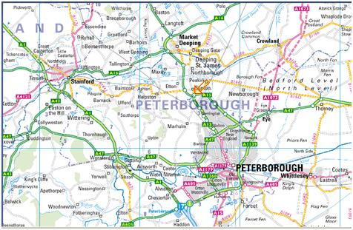

Appendix 1

Staffing structure

General Administrator x2
Cook/Kitchen Assistant x4
Housekeeping x3
Deputy Head Teacher x 1
Teachers x 6
Teaching Assistants x 8
Case Manager x4
Team Leaders x8
Residential Workers x52
Facilities Manager
Head Teacher x 1
Registered Manager
Team Managers x2
Business Manager
Finance Manager
General Administrator x6

Appendix 2

Charter of Rights:

- You have the right to shelter, food, warmth, clothes and to wear your own clothing.
- You have the right to wash, shower, bath and use the toilet in private.
- You have the right to be asked and have considered your wishes for the future.
- You have the right to attend your planning meetings about you, and to have say about your placement and the future. You have the right to be informed in writing as well as verbally of any decision made about you at meetings if you are not there to hear them.
- You have the right to see or speak to your Social Worker or Advocate on your own.
- You have the right to see or speak to your solicitor on your own, to be advised of your legal and civil rights and to have your wishes and feelings taken into account in any court proceedings.
- You have the right to see and speak to the doctor on your own.
- You have the right to refuse medical treatment or examination if you are over 16 years of age (unless you are subject to the provisions of the Mental Health Act).
- You have the right to refuse medical treatment if you are under 16 years of age only if the doctor decides you are fully able to understand the nature of the treatment and the full consequences of your consent or refusal.
- You have the right to receive medical treatment.
- You have the right to see and have contact with your family, unless there is a court order saying otherwise. This includes, having visits from members of your family or other significant people in your life.
- You have the right to use the telephone at reasonable times to contact your parents or those with parental responsibility, social worker, solicitor or Independent Visitor / Advocate.
- You have the right to an Independent Visitor if you are not in regular contact with your parents or those who have parental responsibility for you.
- You have the right to see and speak to your Independent Visitor on your own. You have the right to refuse the Independent Visitor appointed and choose another.
- You have the right to receive education.
- You have the right to follow race, religion, culture or linguistic background and be helped and encouraged to do so. You also have the right to comply with any requirements of your race, religion, culture or linguistic background like dress, diet, and prayer times.
- You have the right to follow special diets and be offered a choice of foods where possible.
- You have the right to see your own mail.
- You have the right to be legally represented in all court appearances.
- You have the right of appeal against any court judgement involving you.
- You have the right to protection from staff members in order to prevent you harming yourself, or other people.

